|  |
| --- |
| **Consulting** |
| WMS Installation & Upgrade Manual |
|  |

 



Content

Installation & Upgrade Guide 3

1.1 Create Database (SQL Server) 3

1.2 Update Database (SQL Server) 3

1.3 Delete the WMS service 4

1.4 WMSPROD site first Install & Upgrade 6

1.5 Backup Set up File 6

1.6 Delete the Web Application 6

1.7 Install the new WMSPROD Site 7

1.8 WMSManager site first Install & Upgrade 8

1.9 Web.config Configuration 8

1.10 WMSManager web.config 8

1.10.1 SQL: 9

1.10.2 HANA 10

1.11 WMSPROD web.config 10

1.11.1 SQL: 10

1.11.2 HANA 11

1.12 WMS Addon 11

1.13 WMS Service installation 11

1.14 Service WMStoSAP Configuration File 14

# Installation & Upgrade Guide

## Create Database (SQL Server)

**Note: This process applies only for first installation**

The first step in our installation is to create the necessary database for WMS transactions. This database is easily created if we follow these steps:

1. We create a database with a name that helps us to identify it quickly (e.g. DepWMS+SAPDATABASENAME). In order to do that, restore the .bak file from the Installation Package. Is is usally named BaseLimpia.bak

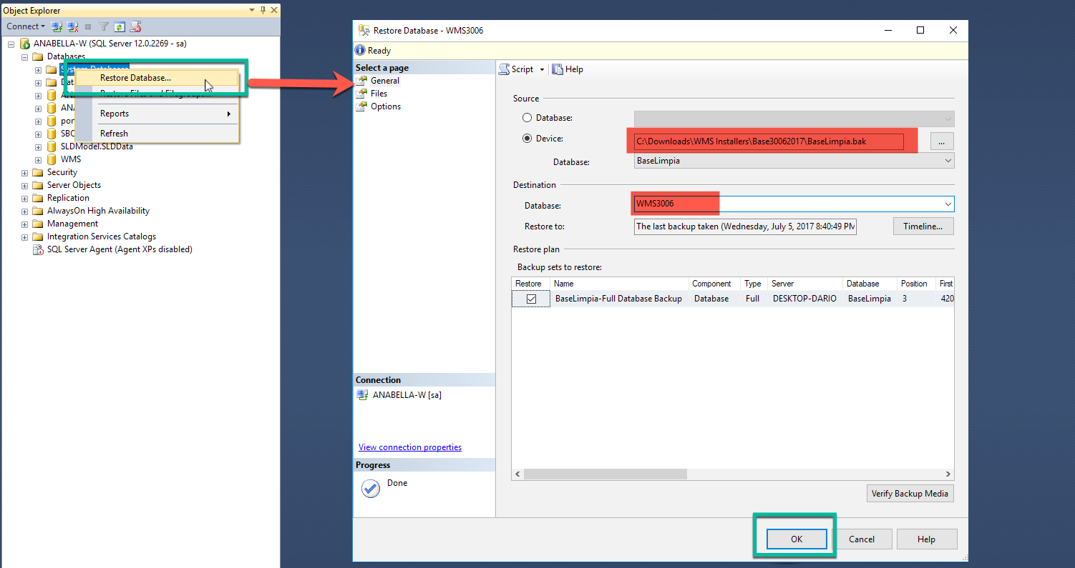

In case you have any error in the import process contact [support@argentis-systems.com](mailto:support@argentis-systems.com)

It is not always necessary but it is suggested to run the UpdateWMS.sql over the recently created database.

## Update Database (SQL Server)

**Note: This process applies only for upgrade**

The first step in the upgrade is to run the update script from the installation package:

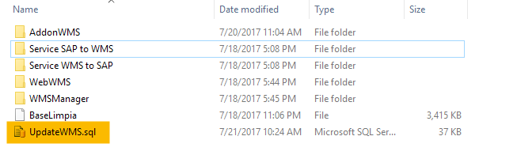

1. 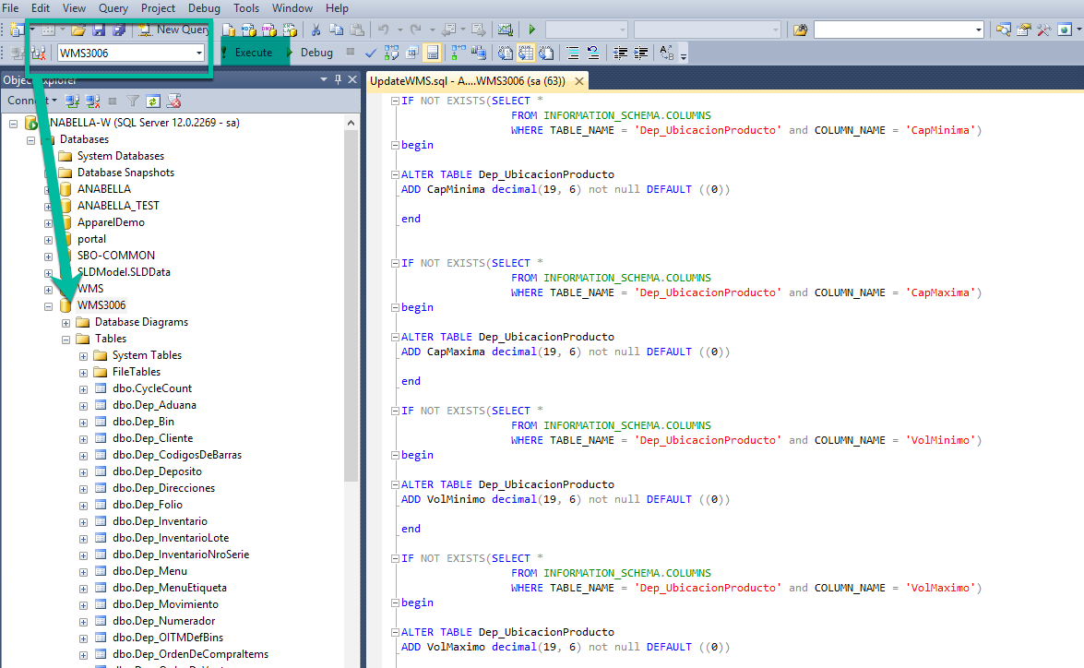Click on the update script and then the SQL Management studio will open. Make sure that the database where you will execute the script is the **WMS database** and not the SAP database.

## Delete the WMS service

**Note: This process applies only for upgrade**

To check where the WMS service was installed. Open the windows services and look for the WMS Sync Service. Right click on it and open the “Properties”.

The folder where it is installed is detailed in **Path to executable.**

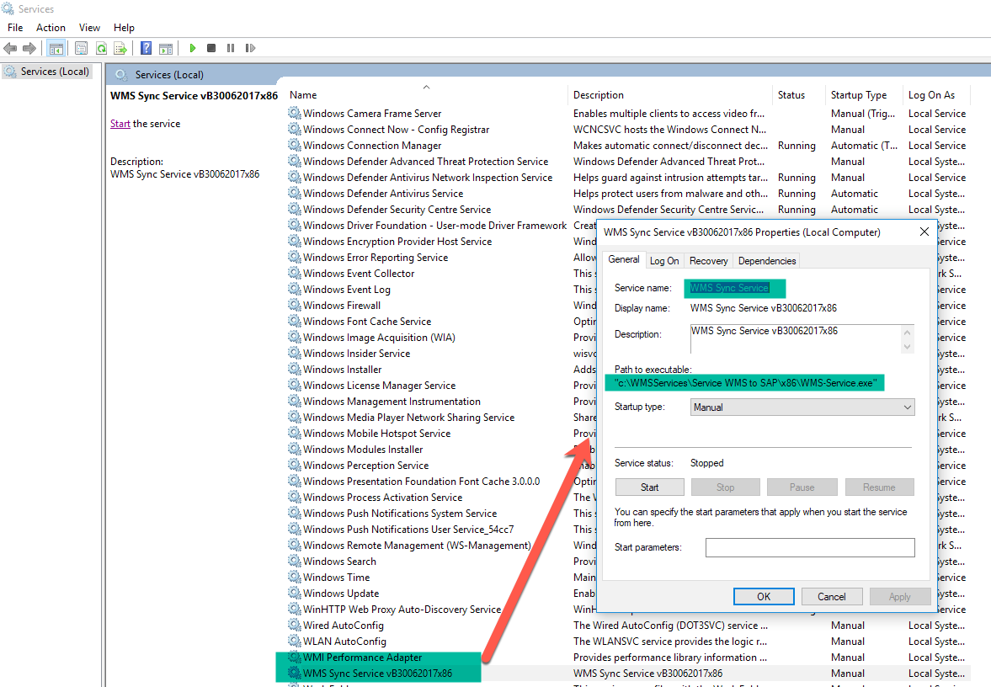

After, run the Command Prompt as an administrator and go to that path.

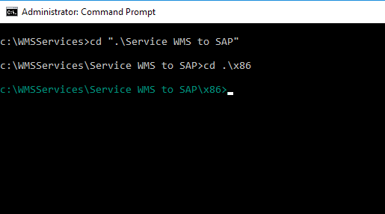

Afterwards, copy the **Service Name** from the service properties window and in the command prompt type **sc delete** and paste the service name between quotes, as shown in the following image:

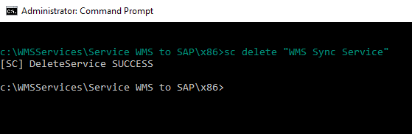

## WMSPROD site first Install & Upgrade

The first step to install or upgrade the web application is to open the IIS console

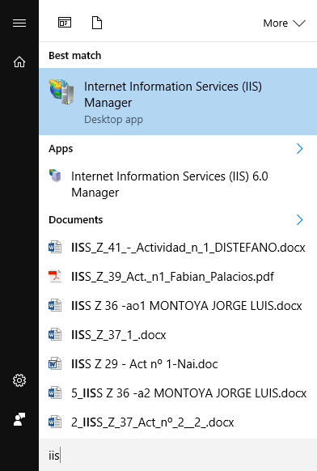

## Backup Set up File

**Note: This process applies only for upgrade**

Before Upgrading the WMSPROD is very important to back up the configuration files that are in the folder C:\inetpub\wwwroot\WMSPROD.

## Delete the Web Application

**Note: This process applies only for upgrade**

Delete the WMSPROD application and content

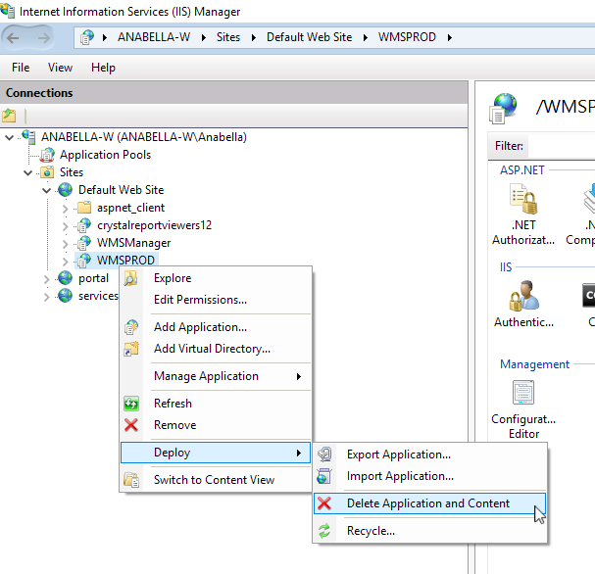

## Install the new WMSPROD Site

**Note: This process applies for first install and upgrade**

Now we must import the new **WMS.zip** application that is located in the WebWMS folder in the installation package.

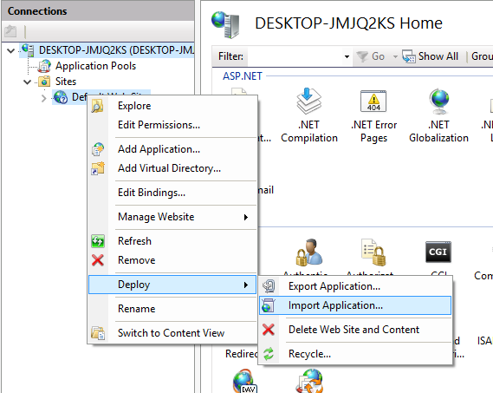

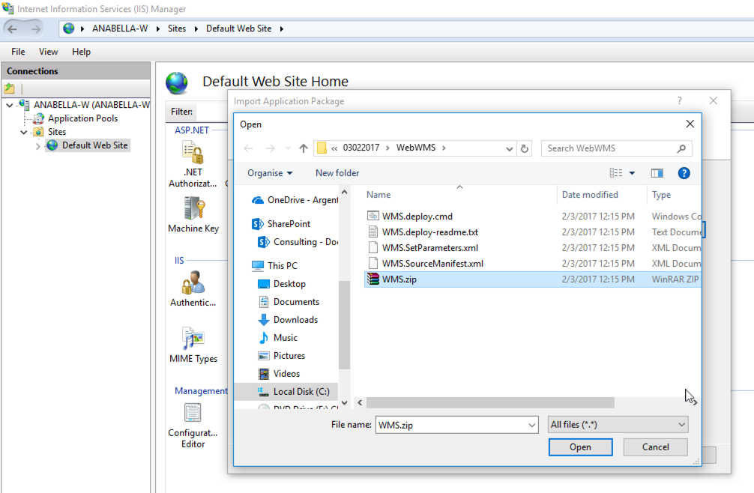

Click several times on Next so you can create the application. If an error message shows up saying “*This Access control list is not in canonical form and therefore cannot be modified”* please go to the WMS – Troubleshooting section.

## WMSManager site first Install & Upgrade

The same process used to install/upgrade the WMSPROD application must be performed for WMSManager. The application to import is **WebManager.zip** which is in the WMSManager folder in the installation package.

## Web.config Configuration

After the WMSManager and WMSProd sites are installed the web.config files need to be configured. It is important to run NotePad as an Administrator to perform the changes or use the NotePad++ application to do this.

## WMSManager web.config

The file that needs to be modified is in C:\inetpub\wwwroot\WMSManager\Web.config

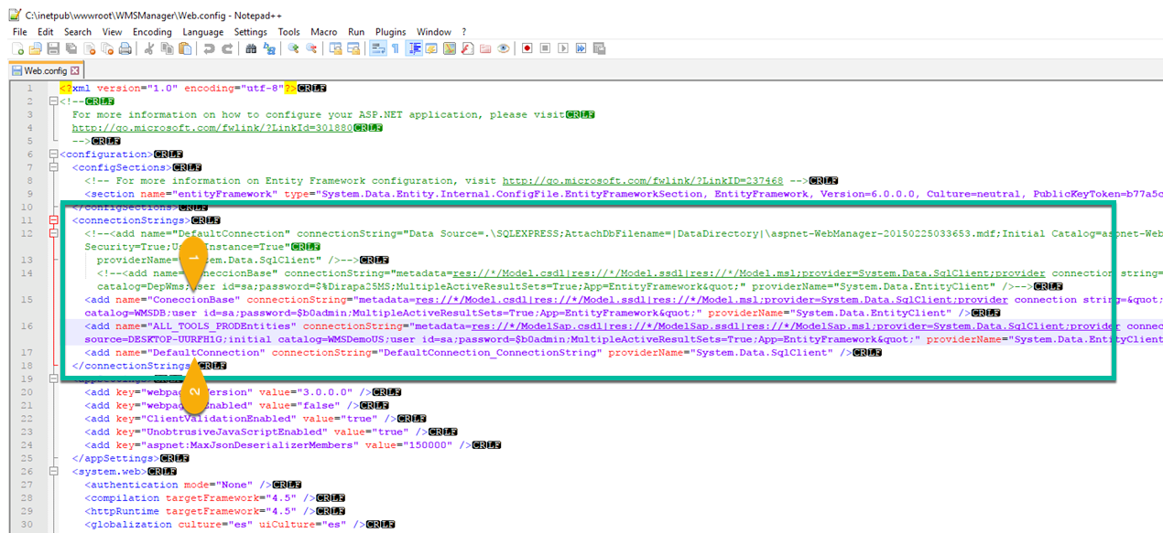

1. Under the ConnectionBase tag, is important to modify:
2. source= is the SQLSERVER NAME where the WMS database is hosted, if it has instance also include it. Example: source=DESKTOP-UURFH1G
3. catalog= is the WMS database: put the name of the database you created in the section Database (SQL Server). Example catalog=WMSDeposit
4. user id= and password= put the SQL user and password to connect to the database. Example user id=sa; password=$b0admin
5. Under the ALL_TOOLS_PRODEntities, tag is important to modify:
6. source= is the SQLSERVER NAME or HANASERVERNAME:PORT where the SAP Company database is hosted, if it has instance also include it. Example: source=DESKTOP-UURFH1G
7. initial catalog= is the SAP Database. Example catalog= WMSDemoUS
8. user id= and password= put the SQL or HANA superuser and password to connect to the database. Example: user id=sa; password=$b0admin

Also, the following needs to be modified according to the SAP Server Type:

### SQL:

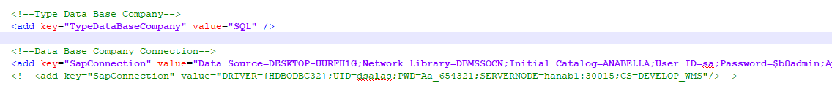

In the TypeDataBaseCompany tag, the ***value*** should be SQL

In the SapConnection tag, modify the following:

* 1. source= is the SQLSERVER NAME where the SAP Company database is hosted, if it has instance also include it. Example: source= DESKTOP-UURFH1G
  2. catalog= is the SAP Company database Name. Example: catalog=ANABELLA
  3. user id= and password= put the sql superuser and password to connect to the database. Example: user id=sa; password=$b0admin

### HANA

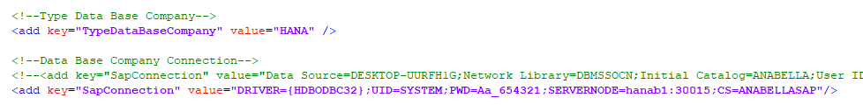

In the TypeDataBaseCompany tag, the ***value*** should be HANA

In the SapConnection tag, modify the following in the:

1. DRIVER= is the ODBC Driver. In order to create the ODBC connection please go to the document “WMS - HANA ODBC Connection”
2. UID= and PWD= put the HANA user and password to connect to the database. Example: user id=SYSTEM; password= Aa_654321
3. SERVERNODE = is the HANASERVERNAME:PORT where the SAP Company database is hosted. Example: catalog= hanab1:30015
4. CS = is the SAP Company database Name. Example: catalog=ANABELLASAP

## WMSPROD web.config

The file that needs to be modified is in C:\inetpub\wwwroot\WMSPROD\Web.config

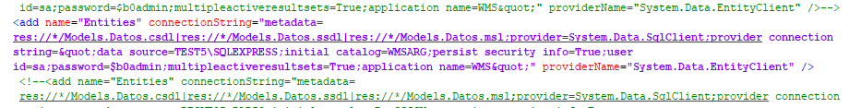

In this file is important to modify the following:

1. source= is the SQLSERVER NAME where the WMS database is hosted, if it has instance also include it. Example: source=TEST5\SQLEXPRESS
2. initial catalog= is the WMS Database: put the name of the database you created in the section Database (SQL Server). Example: initial catalog= WMSARG
3. user id= and password= put the sql user and password to connect to the database. Example: user id=sa; password=$b0admin

Also, the following needs to be modified according to the SAP Server Type:

### SQL:



In the TypeDataBaseCompany tag, the ***value*** should be SQL

In the SapConnection tag, modify the following:

* 1. source= is the SQLSERVER NAME where the SAP Company database is hosted, if it has instance also include it. Example: source= DESKTOP-UURFH1G
  2. catalog= is the SAP Company database Name. Example: catalog=ANABELLA
  3. user id= and password= put the sql superuser and password to connect to the database. Example: user id=sa; password=$b0admin

### HANA



In the TypeDataBaseCompany tag, the ***value*** should be HANA

In the SapConnection tag, modify the following in the:

1. DRIVER= is the ODBC Driver. In order to create the ODBC connection please go to the “WMS - HANA ODBC Connection”
2. UID= and PWD= put the HANA user and password to connect to the database. Example: user id=SYSTEM; password= Aa_654321
3. SERVERNODE = is the HANASERVERNAME:PORT where the SAP Company database is hosted. Example: catalog= hanab1:30015
4. CS = is the SAP Company database Name. Example: catalog=ANABELLASAP

## WMS Addon

Once the database is created in SQL Server, it is possible to install/upgrade the WMS Addon in SAP. To do so, please read the document named “WMS - Addon Install, Uninstall and Upgrade”.

## WMS Service installation

Before installing the service, create a folder on the root disk of the server where the Service Manager is installed. For example, C:\WMSServices. In this folder, we will copy the folder that is inside the installation package called WMS Sync Service\x86 if you will use SAP B1 Client 32-bit , or WMS Sync Service\x64 if you will use SAP B1Client 64-bit .

If you are in the upgrade process, just replace the folder with the new one, but before do a backup.

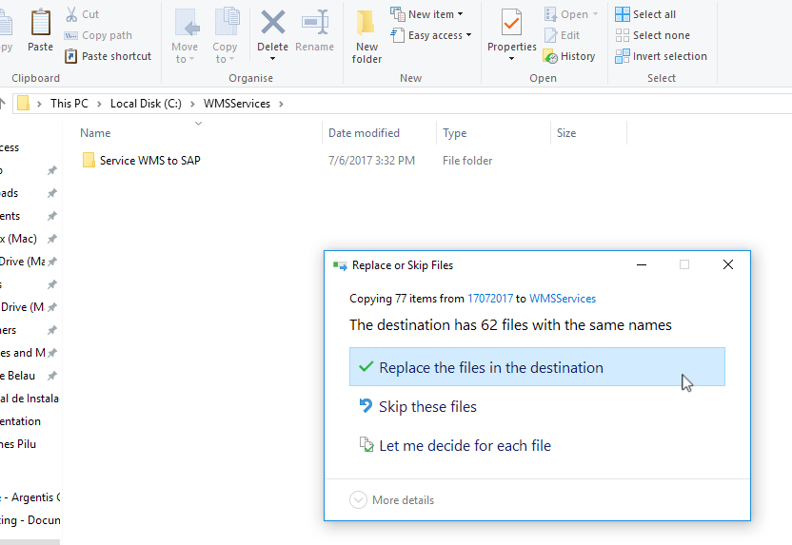

1. Next, run the Command Line as Administrator and access to the path where the WMSService\x86 folder is located if you will use SAPB1Client32-bit or, WMSService\x64 if you will use SAPB1Client 64-bit.

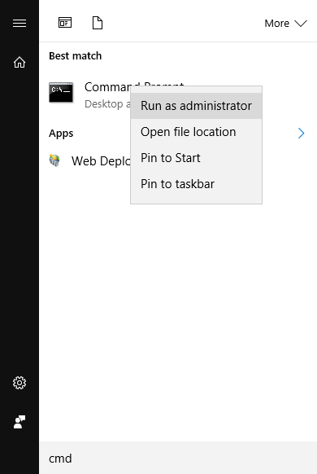

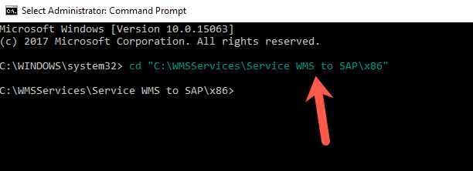

1. Once we are on the path, we must execute the following command that will install the service:

c:\Windows\Microsoft.NET\Framework\v4.0.30319\InstallUtil.exe WMS-Service.exe

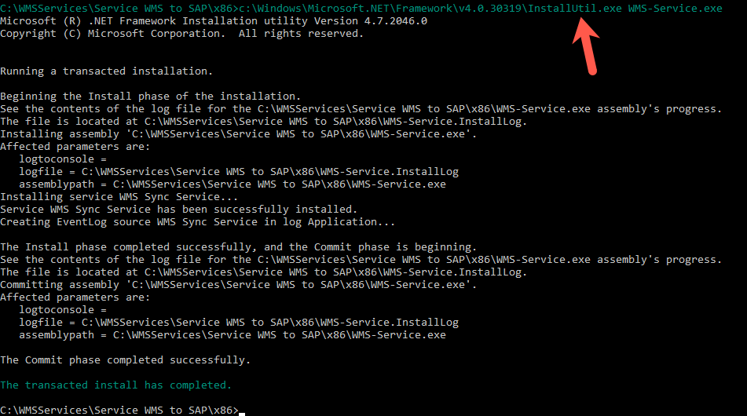

To make sure that the service has been installed check that it in the list of services.

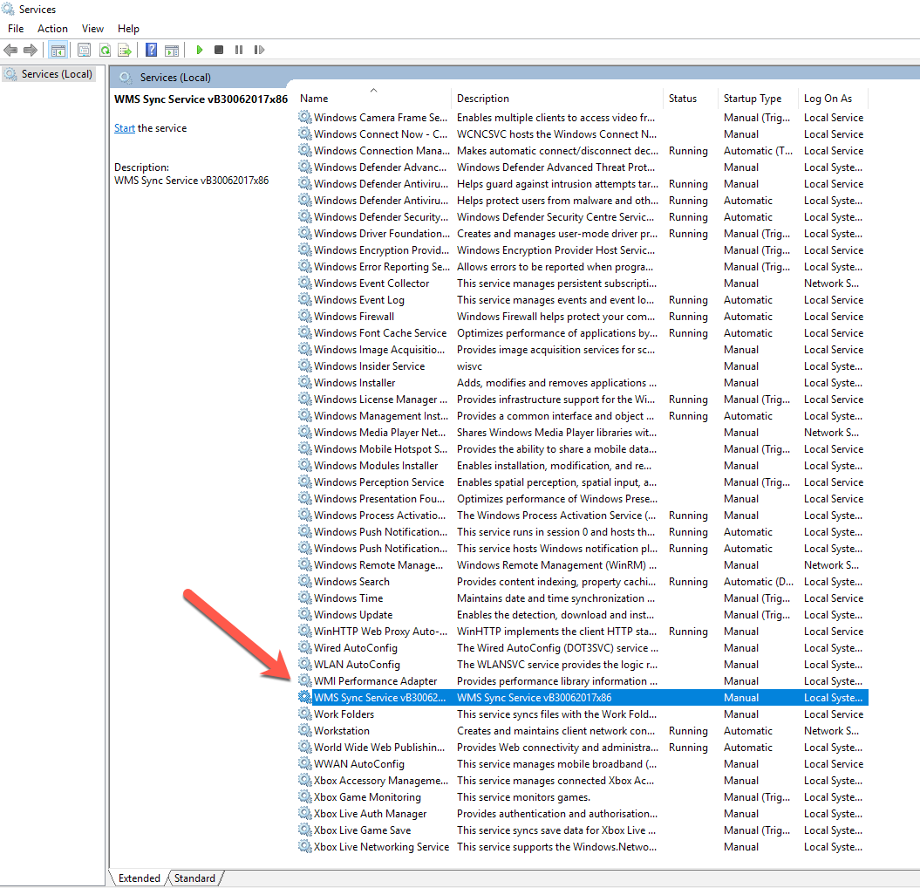

NOTE: If we get the following error message, please go to the Troubleshooting section for more information on how to solve this problem:

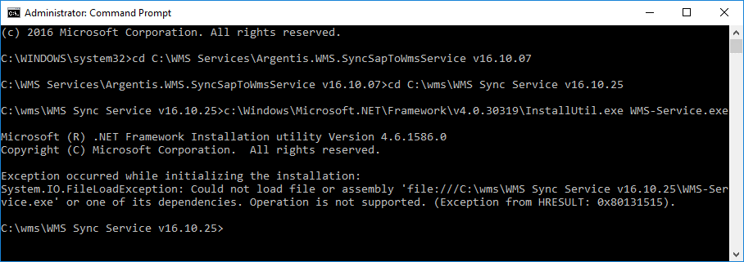

## Service WMStoSAP Configuration File

Once the service is installed, the configuration files need to be modified.

Open the configuration file **WMS-Service.exe.config** with the suggested NotePad ++ editor or run NotePad as an Administrator.

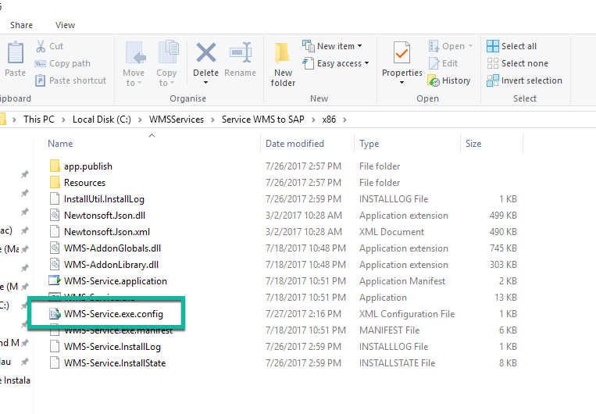

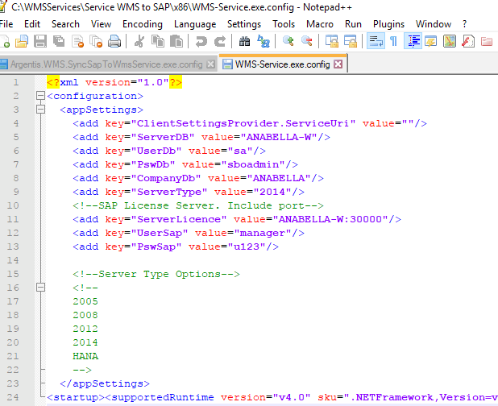

In this file is important to modify:

1. ***ServerDB:*** is the SQLSERVERNAME or HANASERVERNAME:PORT where the SAP Company database is hosted, if it has instance also include it. Example: ANABELLA-W
2. **UserDb:** Database username, ex: sa or SYSTEM for HANA
3. ***PswDb:*** Database password, ex: sboadmin
4. ***CompanyDb:*** SAP database name, ex: ANABELLA
5. ***ServerType:*** Options are: HANA or 2008 for SQL 2008, 2012 for SQL 2012, etc., ex: 2014.
6. ***ServerLicence:*** indicate the license server and port, ex: ANABELLA-W:30000
7. ***UserSap:*** SAP user, ex: manager
8. ***PswSap:*** SAP user password, ex: u123